Raspberry Pi 3b+ instructions for MMDVM board
Prerequisits:
- You must have registered for a DMR-ID at https://radioid.net
- You must have registered for a TGIF account and acquired the security key for your account https://tgif.network
Required hardware: PC Running windows (or linux) Raspberry Pi (I use the 3b+ in this demo) MMDVM Board
Pi-Star is the software you will run on your PI hotspot. Suggested PIs are the 3b or the 0w, not the 4 or 5, due to different GPIO pinouts Download raspberry pi software from this link: https://www.pistar.uk/downloads/Pi-Star_RPi_v4.2.3_18-Apr-2025.zip
This is the software used in Windows to write the downloaded image to an SDCard Download and Run the Balena Etcher installer (This is the windows version) https://github.com/balena-io/etcher/releases/download/v2.1.4/balenaEtcher-2.1.4.Setup.exe
Download from the above link, and then run Now you are ready to install Balena Etcher
MMDVM Boards I know that will work -- you have two options:
- Budget board: https://www.ebay.com/itm/232838404790?_trkparms=amclksrc%3DITM%26aid%3D777008%26algo%3DPERSONAL.TOPIC%26ao%3D1%26asc%3D20250417133020%26meid%3Da9471c94f65149a5a9d6748edaadc0f7%26pid%3D102726%26rk%3D1%26rkt%3D1%26itm%3D232838404790%26pmt%3D1%26noa%3D1%26pg%3D4375194%26algv%3DRecentlyViewedItemsV2WithMLRPboosterAndUpdatedFeatures_BP%26brand%3DUnbranded&_trksid=p4375194.c102726.m162918
2)The second board is of higher quality and many say it's the best. I would purchase the 3.5 display with it as well, it is worth it. This vendor will also sell you a Pi 0w at a reasonable cost, which is similar to the 3b+

https://www.bi7jta.org/shop/duplex-hotspot-board-with-ants-dmr-c4fm-d-star-nxdn-pocsag-13#attr=175,36
This also provides a fan for the unit, as cooling is an issue. PoE is power over ethernet. If your ethernet switch supports PoE, this will be a good option to purchase.
3) Optional Waveshare PoE Hat(e) adaptor for the PI3b+ boards:
https://www.aliexpress.us/item/3256807728772978.html?spm=a2g0o.cart.0.0.5c8e38daaGO8La&mp=1&pdp_npi=5%40dis!USD!USD 18.93!USD 13.44!!USD 13.44!!!%40210312d517604449469382222e70bd!12000042826079259!ct!US!6096279423!!2!0&_gl=15xil8u_gcl_awR0NMLjE3NjA0MDAwMjcuQ2owS0NRandvNjNIQmhDS0FSSXNBSE9IVl9WZ245NS1sZFhod2NMVGhqZ2U5U2lMVEF0bHpLMk5xZnh6N013Rl94anV4SWJRYXE3WnVtSWFBcFNuRUFMd193Y0I._gcl_dcR0NMLjE3NjA0MDAwMjcuQ2owS0NRandvNjNIQmhDS0FSSXNBSE9IVl9WZ245NS1sZFhod2NMVGhqZ2U5U2lMVEF0bHpLMk5xZnh6N013Rl94anV4SWJRYXE3WnVtSWFBcFNuRUFMd193Y0I._gcl_auMjA3MDgxNDMxLjE3NTQ3MDAxODQ._gaNDU0MDQ3MTgwLjE3NjA0NDQ5NDU._ga_VED1YSGNC7*czE3NjA0NDQ5NDUkbzEkZzEkdDE3NjA0NDQ5NDckajU4JGwwJGgw&gatewayAdapt=glo2usa
A lot of folks use these to assure a good power supply to the board. Otherwise you'll need the correct micro USB 5V, 3A walwart power supply, which are difficult to source these days. Be sure to select the US model or you'll get the wrong plug. I bought some from here:
https://www.aliexpress.us/item/3256802712114414.html
I recommend a 32gb SD card to install Pi-Star on. You can go larger if you like, but I wouldn't go smaller. You can buy them for under three dollars from here. Note, I'd get several of them for the purpose of playing with other software.
https://www.aliexpress.com/ssr/300000512/BundleDeals2
You will also need a USB reader for SD memory cards.
https://www.aliexpress.com/ssr/300000512/BundleDeals2
Video reference on getting started with the raspberry pi:
https://www.raspberrypi.com/documentation/computers/getting-started.html
Unzip the Pi-Star OS image you just downloaded:
You should see two files in today's downloads within File Explorer, they are Pi-Star and balena Etcher
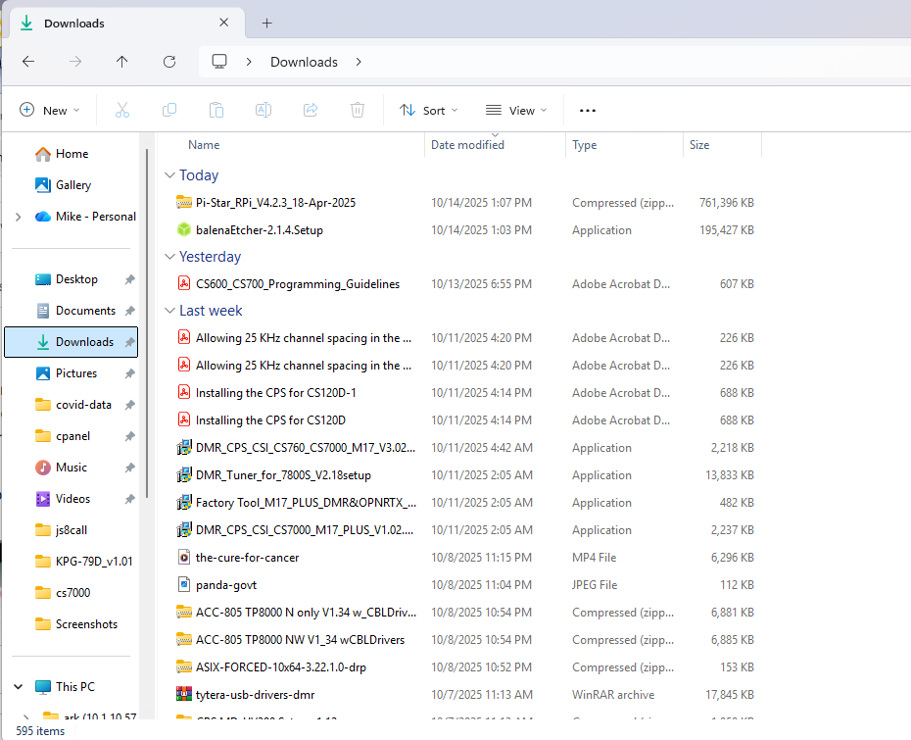
Right click on the Pi-Star filename and then click on "Extract All...."

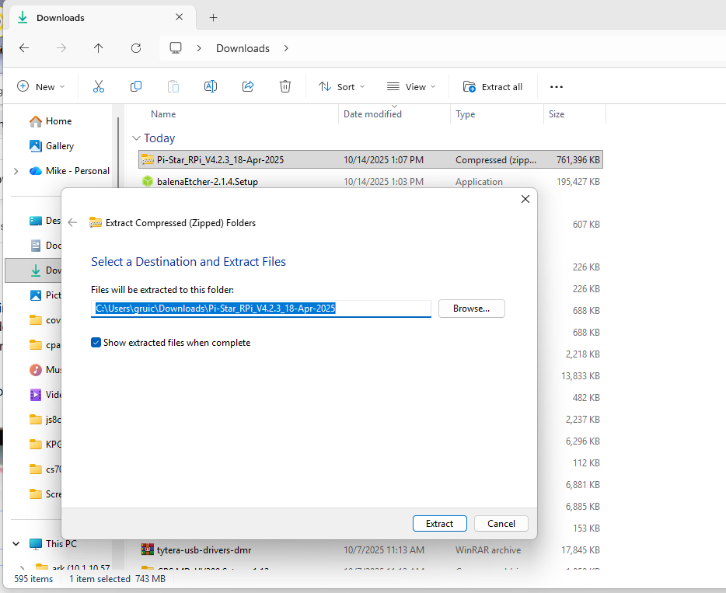
A new folder is created with the image file inside of it
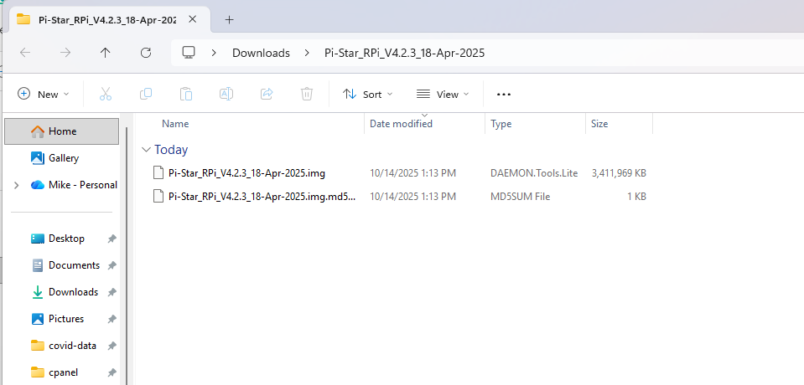
A new folder is created and a new window will pop open with these contents. We will be using the filename ending with .img and writing that to our SDCard.

Make note of the filename here, we will revisit this location in a moment. Next insert your SD Card into the USB carrier and then put that into the USB slot in the PC.
Next run Balena Etcher from the Downloads. Install it and run it. Select "Flash from file"
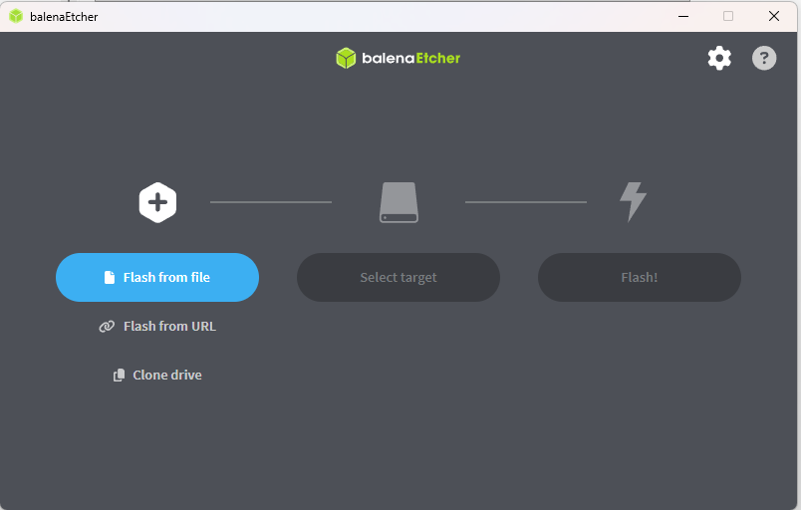
Select the image file for Pi-Star we just created out of downloads directory
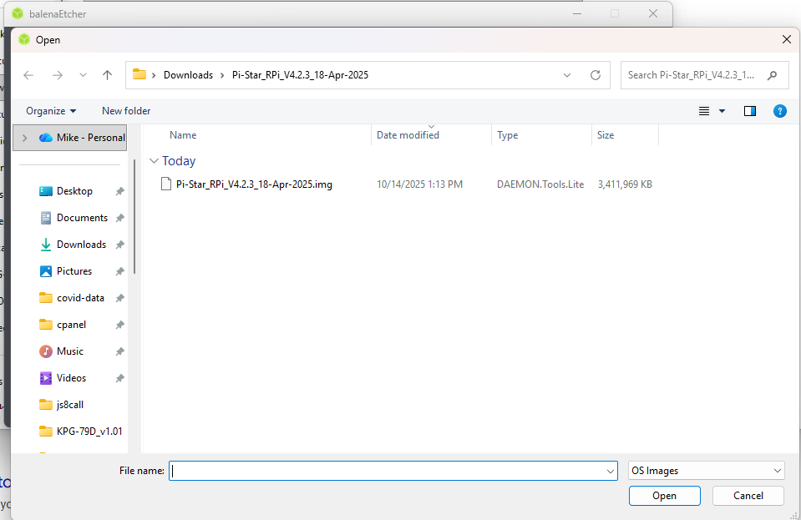
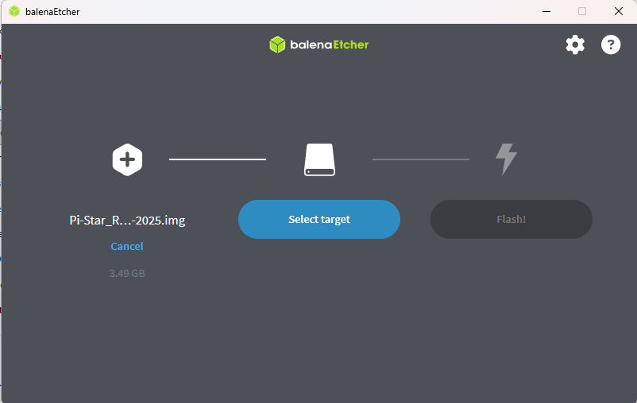
Next select the target. Click on "Select Target"
You should see a USB drive of some sort. Note the drive manufacture probably will not match the brand of flash you purchased. Click on the USB drive you are going to write to. Make 100% sure you got this correct.
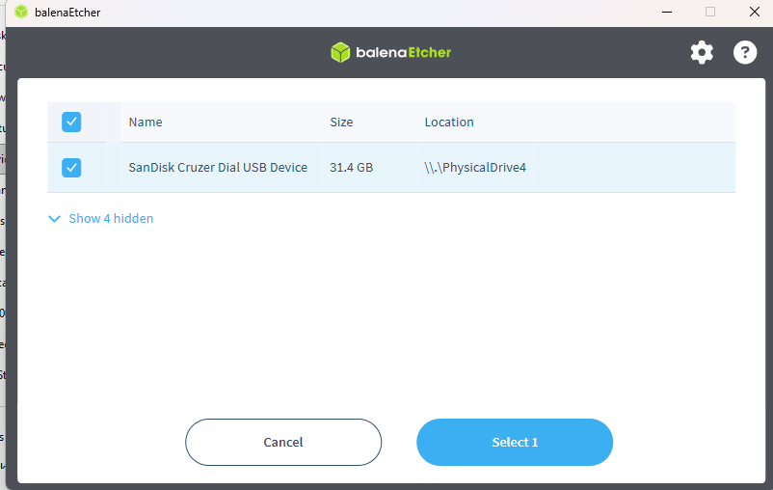
You should now see:
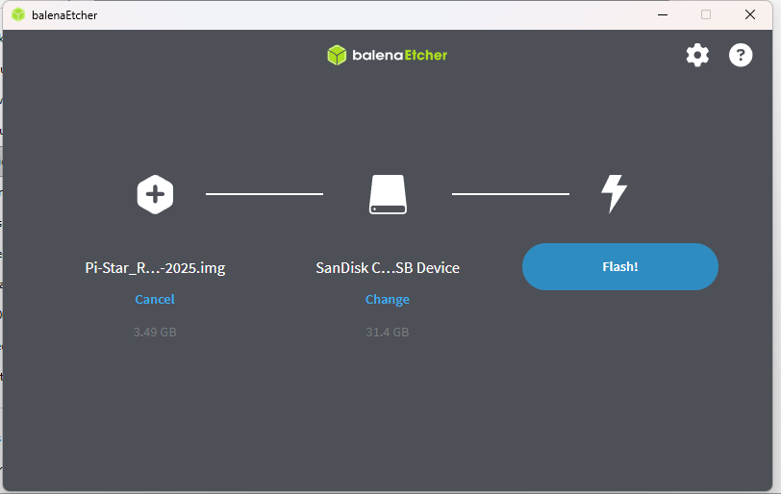
Now that you have the drive select, you're ready to flash:
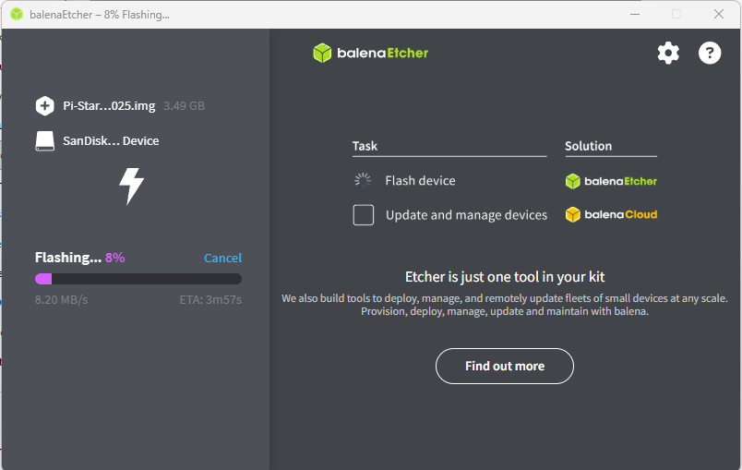
This could take between 5-10 minutes to write the image, sit back and watch it go.

When complete, eject the USB drive and remove the SD card and insert it into the carrier bay in your Raspberry Pi. Connect power and ethernet to your raspberry pi. Give it a minute and then your Pi will be booted up. Watch the screen closely, as you should be able to see the IP addressed assigned by DHCP server.
Open a web browser and navigate to the raspberry pi's webpage. The default login will be pi-star and the password is raspberry
You will see an unconfigured dashboard (this screenshot things are configured) Click on Configuration on the upper right
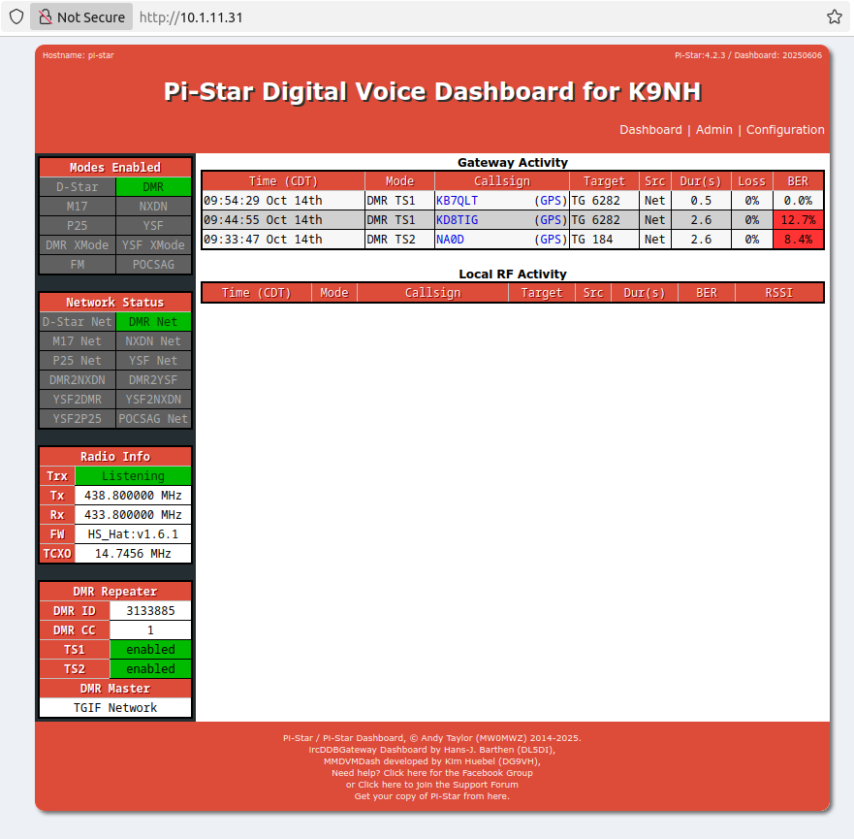
For each section of the config, you have to click on "Apply Changes" button once that section is completed. Changes don't happen until you do so. The first section is "Control Software" Select the following: Controller Software: MMDVMHost Controller Mode: Duplex Repeater Click on "Apply Changes"
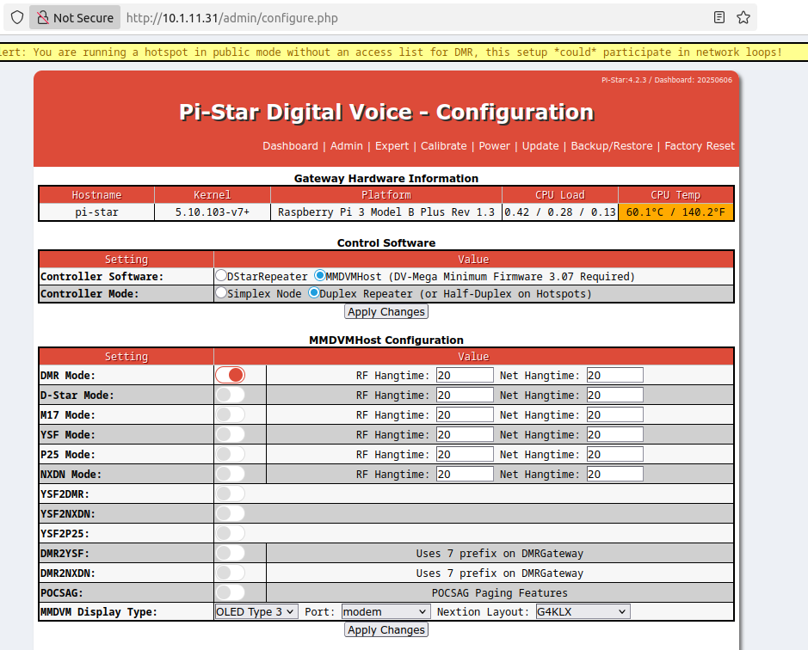
In the MMDVMHost Configuration section, enable DMR MODE by moving the slider button to the right.
For MMDVM Display Type, the small one inch screens using the following config: Display Type: OLED Type 3 Port: modem Nextion Layout: G4KLX
For the larger Nextion screen use Display Type: Nextion Port: /dev/ttyNextionDriver Nextion Layout: ON7LDS3 L3 HS
Click on Apply changes under MMDVMHost Configuration
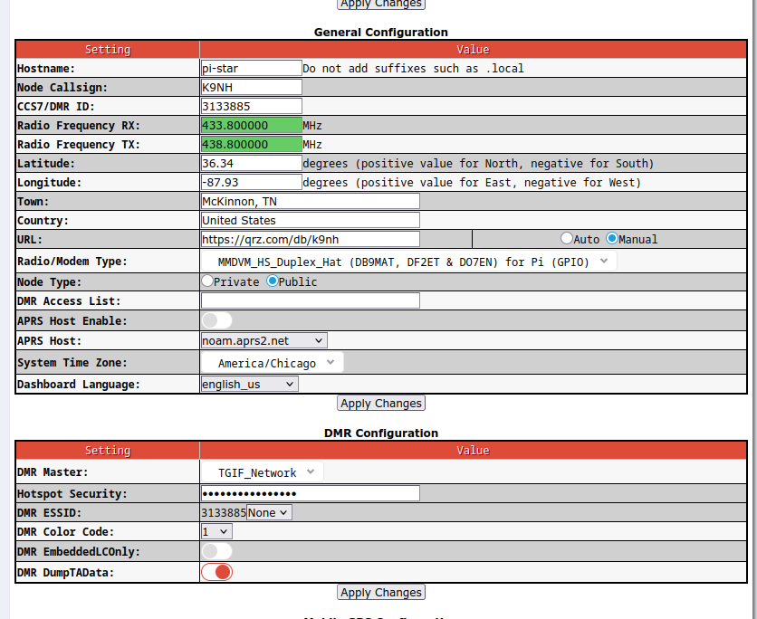
Hostname <-- this is the hostname your device will have on your network. If you have more than one pi-star, number them sequentially accordingly. If you manage a DNS and DHCP server, it'd be worth adding them in as an infinite lease and defining the Fully Qualified Domain Name to it's address.
Hostname: pi-star
Node Callsign: This is the device's callsign. Again, if you have multiple, you can append -01, -02 to the end or /01 /02, etc
Callsign: K9NH
CCS7/DMR ID <-- This is the DMR ID assigned to you via https://dmrid.net This is public information and it is how you are identified on any DMR based network.
CCS7/DMR ID: 3133885
Radio RX/TX <-- This is the transmit and receieve on your Pi-Star. Full Duplex pistars can send and receive at the same time and can be used as mini repeaters. In fact, there is an add on board called a pi-star repeater board that will broker the TX/RX to the pi-star to allow you to take off the shelf radios and create full blown repeaters out of them. On a simplex pi-star, you would only have a single frequency.
Radio Frequency RX: 433.8 Radio Frequency TX: 438.8
Latitude/Longitude <-- I look up my house using google maps to get this information Latitude: 36.34 Longitude: -87.93
Town <-- What town and state you live in Town: McKinnon, TN
Country: United States
URL <-- Choose Manual radio button first and then enter URL You can put any url in here you want, but I just put my QRZ page in to keep it simple.
URL: https://qrz.com/db/k9nh
Radio/Modem type <-- This may take some trial and error. Since the MMDVM is open source hardware, there are many different options to choose from.
Both duplex boards same to use this ok:
Radio/Modem Type: MMDVM_HS_DUPLEX_HAT (DB9MAT, DF2ET & DO7EN) for Pi (GPIO)
Node Type: Public
DMR Access List: leave blank for now
APRS is a radio tracking protocol for digital messaging. Disable for now
APRS: Disable APRS
Host: noam.aprs2.net System Time Zone: America/Chicago
Dashboard_Language: English_US

Click "Apply Changes"

DMR Configuration: This is where you define your connection to the TGIF Network
DMR Master <-- This defines which DMR network you will be using DMR Master: TGIF_NETWORK
Hotspot Security <-- This defines the shared secret between you and TGIF, it is basically a device/api password You can find this in your TGIF account security settings Hotspot Security: xxxxxxxxxxxxxxxxxxxxx
DMR ESSID <-- ESS=extended service set. You can take your DMR ID and add suffix numbers to it if you are running multiple DMR devices 01-99 are accepted suffixes DMR ESSID: 313385
DMR Color Code <-- Think of this as a digital PL tone. color has to match to send/receive traffic Most repeaters and hotspots will default to 1, which is usually what folks use DMR Color Code: 1
DMR EmbeddedLCOnly: leave disabled DMR DumpTAData: used for debugging. If you are having issues, leave this on

Click "Apply Changes"
Mobile GPS Configuration Section Unless you have a GPS, Leave this setting disabled (it is disabled by default)
Private access is considered "on the subnet" Public access is considered "off the subnet" I changed my ssh to public, because I have multiple subnets in my house Note: you should change the default pi-star user password at the bottom of the config.

Firewall Configuration Section

Dashboard Access: Private

ircDDBGateway Remote: Private

SSH Access: Public Auto

AP: On

uPNP: On

Click "Apply Changes"
Wireless Configuration
Once you configure your wireless, you will need to reboot in order for it to take affect. You need to know your wifi password, and it will go into the PSK field (psk=pre-shared-key) Note that when it scans for networks, you will see all the SSID you can connect to, choose the appropriate one and provides it's password in the PSK field. When completed, click the "Set PSK" button. You may need to "scan" for networks and have it present a list of networks before connecting to a network. Be sure to set your country properly
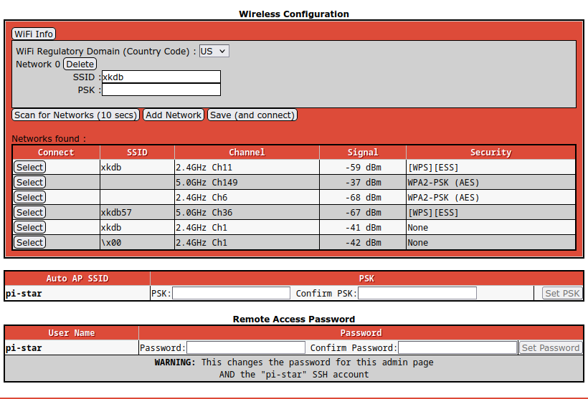
The remote access password at the bottom is the pi-star user password. You will change this and click on "Set Password" button to confirm.

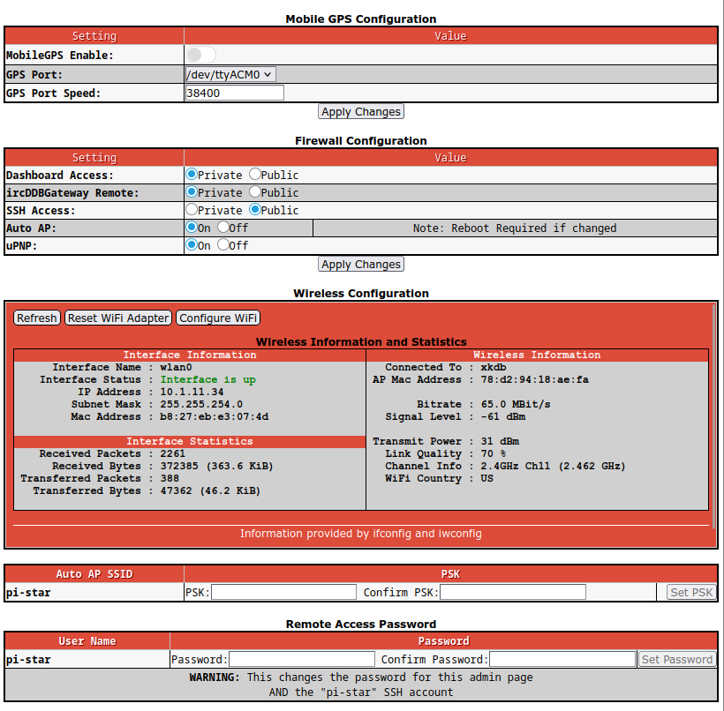
You should now be ready to go .

